AULTMAN HEALTH
I8 Cerner GL Transaction
Inbound Interface (Cerner -> FSM)

Document Properties
Author | Paolo Enrico Vicente, Daryll Blu Papellero
Creation Date | 02/06/2023
Last Updated
Document Reference | ANA-050 + DES-020
Version | 1.0

Document Control

Change Record
1
Date | Author | Version | Change Reference
02/06/2023 | Paolo Enrico Vicente | 1.0 | Initial draft: Executive Summary, Functional Specification, Testing Process
MM/dd/yyyy | <Technical Resource> | 1.1 | Initial draft: Technical Specifications (Solution Overview)
MM/dd/yyyy | <Functional Resource> | 1.1 | Submitted for client approval
MM/dd/yyyy |  | 1.1 | Client approved version
MM/dd/yyyy | <Functional Resource> | 2.0 | Modified approver notification verbiage (FR 1.5)

Contents
1 Document Control 2
1.1 Change Record 2
2 Executive Summary 4
2.1 Business Objectives 4
2.2 Assumptions 4
3 Functional Specifications 5
3.1 Overview 5
3.2 Functional Requirements 5
3.3 Business Process Flow 6
3.4 Field Mapping 6
4 Technical Specifications 7
4.1 Solution Overview 7
4.2 Tezcchnical Configurations 7
5 Testing Process 15
6 Signature 17
6.1 Functional Specification 17
6.2 Technical Specification 17
7 Appendix 18
7.1 Client Approval 18
7.2 Sample Vendor Files 18
7.3 LPL Codes 18
7.4 Process Flow 18

Executive Summary
Aultman Health Foundation (AHF) has a business relationship with Cerner who manages the GL Transactions that are being sent daily to the Aultman Health Finance department.
This document describes the functional requirements to upload the GL Transactions from a Third Party Vendor Cerner to the Global Ledger Transaction Interface of the Infor Cloudsuite Financials (FSM).

Business Objectives
This interface intends to change the process by picking up the GL Transaction file from the Third Party vendor Cerner and load it into the new Global Ledger of the Infor Cloudsuite Financial via GLTransactionInterface business class.

Assumptions
This specification assumes that the following statements are true. Any changes can result in a change order and will be managed using the change order process as defined in the Service Workorder.
- The interface file generated by the provider is not in FSM acceptable format ready and will be used to update Cloudsuite Financials.
- Validation will not be performed during the file import process, rather, the validation will take place during the GL Transaction interface process from import business classes to General Ledger Transaction business classes
- No crosswalk in accounts or any finance dimensions will be used. All accounts are one to one relationship.
- File naming convention will be provided by AHF for the source file.

Functional Specifications

Overview
The inbound interface will use Infor Cloudsuite Financials functionality to load GL Transaction entries from a third party vendor Cerner to Infor CSF Global Ledger via GLTransactionInterface business class.

Functional Requirements

Functional Requirement ID | Requirement Definition
FR 1.1 | AHF needs a way to systematically pick up the GL Transaction file generated by Cerner and load it to the Infor FSM GL Transaction Interface.
FR 1.2 | GL Group identified by AHF needs to be notified when GL Transaction files have been loaded successfully.
FR 1.3 | Interface Delivery Method
FR 1.4 | Input file will be converted to FSM format
FR 1.5 | GLTrans mapping
FR 1.6 | Error Handling
FR 1.7 | Successful Data Notification
FR 1.8 | Cerner files needs to be archived. The Infor cloud software must retain the delivered Cerner input files for at least 31 days. These archived files must be accessible by the IT and Finance teams.  Processed files must be archive by Aultman and move to its own SFTP location.

- File generated by cerner
File will be generated from Cerner, then load it to FSM GL Transaction Interface. The file will be modified to FSM upload format.
- GL group to be notified
Group or Individual that will be notified if there are error during interface (run Interface in Detail) or after successful upload per run group.

- interface delivery method
Interface Type | Inbound
Source System | Infor Financials and Supply Management (FSM)
Target System | Client FTP/SFTP location
Frequency | Weekly
Trigger | File Channel
File Location | sftp.aultman.com ?
File Name | Cerner_GLTrans_YYYYMMDDhhmm
File Format | Text file
Input File Location to AHF SFTP | /GLTrans/Cerner/<YYYY>/
Archive Input File Location to AHF SFTP | /GLTrans/Archive/Input/Cerner/<YYYY>/
Archive Output File Location to AHF SFTP | /GLTrans/Archive/Output/Cerner/<YYYY>/
Archive File Name | Cerner_GLTrans_RunGroup_YYYYMMDDhhmm

- MODIFICATION OF Cerner FILE TO fsm format
IPA will automatically modify the Cerner file to FSM format then upload it to FSM for import.
*Parameters to use when running Interface
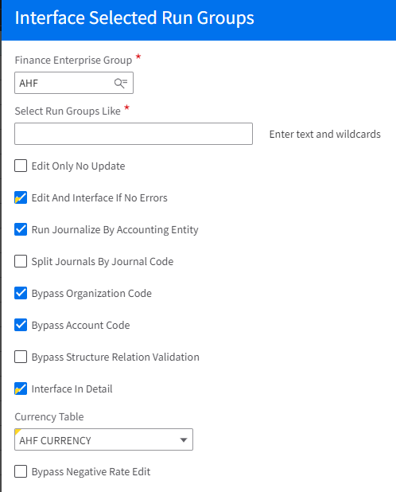

- Cerner detail mapping
Detail mapping is provided below under 3.4 Field Mapping.

- error handling
The IT Support will be notified if any error has been encountered during processing.
To | IT@Aultman?
Cc
From | FSM_notification@infor.com
Subject | Cerner GL Trans ERROR – Cerner_GLTrans_YYYYMMDDhhmm
Body Text | Cerner GL Trans has an error. Please check and determine the correction needed. Ensure the record in Cloudsuite is corrected.  Technical details are as follows:  Run Group:  Date:  Work Unit:
- successful data notificaiton
A group of users will be notified via email upon successful export of the output file.
To | GLadmin@aultman.com ?
Cc
From | FSM_notification@infor.com
Subject | Cerner GL Trans SUCCESSFUL – Cerner_GLTrans_YYYYMMDDhhmm
Body Text | Cerner GL Trans File has been imported to GLTransaction Business class successfully.  Run Group:  Date:  Technical details are as follows:  Work Unit:  Process:

- processed files to be archived
After consumption in FSM, file will be archived to another directory. Client will be responsible to Archive / move the file to their own SFTP location. (to be decided)

Business Process Flow
Legend:
Process outside FSM / Manual process
IPA driven
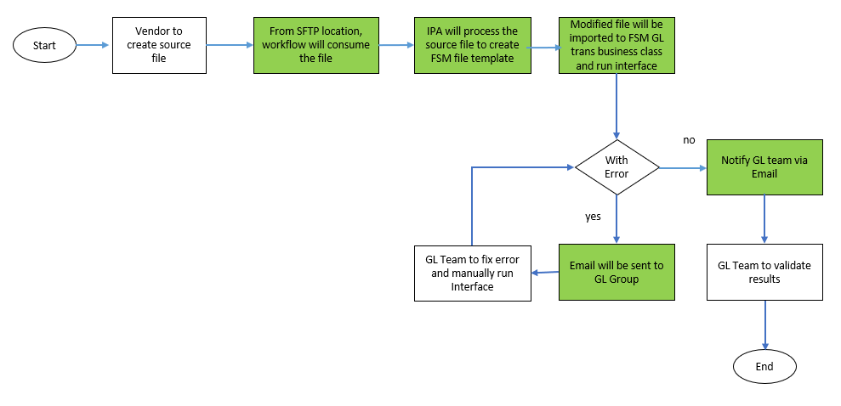

Field Mapping

Field Mapping for GL transaction interface

GLTransactionInterface (red are required fields)
The target column can be used by the Vendor for the future state GL file being sent to AHF

S No. | Target (GLTransactionInterface business class) | Input/source file | Remarks | Type | Size | Required
1 | UniqueID |  |  | UniqueID
2 | FinanceEnterpriseGroup | AHF | The Finance Enterprise Group for the transaction | AlphaUpper | 4 | Y
3 | GLTransactionInterface.RunGroup | Run Group  Column A | A user-defined unique identifier used to group together a set of records to process selectively or concurrently. | AlphaUpper | 30 | Y
4 | GLTransactionInterface.SequenceNumber | Sequence Number (Increment by 1) | A user-defined unique identifier assigned to each transaction to be transferred into the CSF system. If all other key fields are alike, this may be used so that no duplicates will occur. | Numeric | 12 | Y
5 | GLTransactionInterface_user_fields |  |  | Alpha | 1000
6 | AccountingEntity | Company  Column C  Remove leading zeroes | This is the accounting entity that is originating the entry. | AlphaUpper | 12 | Y
7 | Status | 0 | Valid values are:  0-Unreleased  1-Error  2-Budget Edit | Numeric | 1
8 | OrganizationCode | Blank | An optional user-defined field that contains the CSF Accounting Entity and accounting unit. This field determines what accounting entity and accounting unit a record will convert to. | AlphaUpper | 40
9 | ToAccountingEntity | Company  Column C | The to accounting entity the transaction will post to | AlphaUpper | 12
10 | AccountingUnit | Not Applicable | The accounting unit the transaction will post to | AlphaUpper | 25
11 | AccountCode | Old-Acct-Nbr  Column E  First 6 digits | This field can be used 2 ways - one is as a user-defined field that will crosswalk the account to the CSF account. It can also be the actual account to be posted to. | AlphaUpper | 26 | Y
12 | GeneralLedgerEvent | source code  Column F | Used to indicate where the transaction was created.  TC will default if this field is left blank. | AlphaUpper | 15
13 | JournalCode | program_code  Column P |  | AlphaUpper | 6
14 | TransactionDate | Date  Column G | Valid values are:  YYYYMMDD | Date
15 | Reference | Reference  Column H | The reference number associated with the transaction. | Alpha | 40
16 | Description | Description  Column I | User-defined description of the transaction record | Alpha | 60
17 | CurrencyCode | Currency_ code  Column J | User-defined currency code used if the transaction is not in the accounting entity's base currency. | AlphaUpper | 5
18 | UnitsAmount | Units Amount  Column K | Contains the transaction units amount. | Decimal | 18.2
19 | TransactionAmount | Tran Amount  Column L | Transaction Amount (positive or negative) in currency to be posted | Decimal | 19.3
20 | ReportCurrencyAmount.FunctionalAmount.EnteredCurrencyRate |  |  | Decimal | 31.15
21 | ReportCurrencyAmount.FunctionalAmount.EnteredCurrencyAmount |  |  | Decimal | 19.3
22 | ReportCurrencyAmount.AlternateAmount.EnteredCurrencyRate |  |  | Decimal | 31.15
23 | ReportCurrencyAmount.AlternateAmount.EnteredCurrencyAmount |  |  | Decimal | 19.3
24 | ReportCurrencyAmount.AlternateAmount2.EnteredCurrencyRate |  |  | Decimal | 31.15
25 | ReportCurrencyAmount.AlternateAmount2.EnteredCurrencyAmount |  |  | Decimal | 19.3
26 | ReportCurrencyAmount.AlternateAmount3.EnteredCurrencyRate |  |  | Decimal | 31.15
27 | ReportCurrencyAmount.AlternateAmount3.EnteredCurrencyAmount |  |  | Decimal | 19.3
28 | ReportCurrencyAmount.ToFunctionalAmount.EnteredCurrencyRate |  |  | Decimal | 31.15
29 | ReportCurrencyAmount.ToFunctionalAmount.EnteredCurrencyAmount |  |  | Decimal | 19.3
30 | ReportCurrencyAmount.ToAlternateAmount.EnteredCurrencyRate |  |  | Decimal | 31.15
31 | ReportCurrencyAmount.ToAlternateAmount.EnteredCurrencyAmount |  |  | Decimal | 19.3
32 | ReportCurrencyAmount.ToAlternateAmount2.EnteredCurrencyRate |  |  | Decimal | 31.15
33 | ReportCurrencyAmount.ToAlternateAmount2.EnteredCurrencyAmount |  |  | Decimal | 19.3
34 | ReportCurrencyAmount.ToAlternateAmount3.EnteredCurrencyRate |  |  | Decimal | 31.15
35 | ReportCurrencyAmount.ToAlternateAmount3.EnteredCurrencyAmount |  |  | Decimal | 19.3
36 | ReportCurrencyAmount.ProjectAmount.EnteredCurrencyRate |  |  | Decimal | 31.15
37 | ReportCurrencyAmount.ProjectAmount.EnteredCurrencyAmount |  |  | Decimal | 19.3
38 | ReportCurrencyAmount.ReportAmount1.EnteredCurrencyRate |  |  | Decimal | 31.15
39 | ReportCurrencyAmount.ReportAmount1.EnteredCurrencyAmount |  |  | Decimal | 19.3
40 | ReportCurrencyAmount.ReportAmount2.EnteredCurrencyRate |  |  | Decimal | 31.15
41 | ReportCurrencyAmount.ReportAmount2.EnteredCurrencyAmount |  |  | Decimal | 19.3
42 | ReportCurrencyAmount.ReportAmount3.EnteredCurrencyRate |  |  | Decimal | 31.15
43 | ReportCurrencyAmount.ReportAmount3.EnteredCurrencyAmount |  |  | Decimal | 19.3
44 | ReportCurrencyAmount.ReportAmount4.EnteredCurrencyRate |  |  | Decimal | 31.15
45 | ReportCurrencyAmount.ReportAmount4.EnteredCurrencyAmount |  |  | Decimal | 19.3
46 | ReportCurrencyAmount.ReportAmount5.EnteredCurrencyRate |  |  | Decimal | 31.15
47 | ReportCurrencyAmount.ReportAmount5.EnteredCurrencyAmount |  |  | Decimal | 19.3
48 | System | System  Column O | A two-character code representing an application used within the CSF system (for example, GL=Global Ledger, AP=Payables).  GL will default if left blank | AlphaUpper | 2
49 | AutoReverse | Auto Rev  Column Q  HardCoded = N | Auto reversal is the process of reversing the transaction. If you select auto reverse, Period Closing (GL199) creates a reversing journal entry in the next period for this transaction. | Boolean
50 | PostingDate | Posting Date  Column R | This date, assigned to the journal entry, determines what period and year the transaction (journal entry) will reside in after completing the Transaction Conversion process.  Valid values are:  YYYYMMDD | Date |  | Y
51 | Project | Activity  Column S | The project the transaction will post to | AlphaUpper | 25
52 | FinanceDimension1 | Old Company column D  Last 5 digit |  | AlphaUpper | 15
53 | FinanceDimension2 |  |  | AlphaUpper | 15
54 | FinanceDimension3 | Acct-Category  Column T |  | AlphaUpper | 15
55 | FinanceDimension4 |  |  | AlphaUpper | 15
56 | FinanceDimension5 |  |  | AlphaUpper | 15
57 | FinanceDimension6 |  |  | AlphaUpper | 15
58 | FinanceDimension7 |  |  | AlphaUpper | 15
59 | FinanceDimension8 |  |  | AlphaUpper | 15
60 | FinanceDimension9 |  |  | AlphaUpper | 15
61 | FinanceDimension10 |  |  | AlphaUpper | 15
62 | Ledger |  | The core ledger will default if an alternative ledger is not selected | AlphaUpper | 20
63 | DocumentNumber | Document-NBR  Column U | A reference field used for sub-system journaling by document. If the company you are converting to is journaling by document, this field will be used to determine where to batch a new journal entry. | Alpha | 30
64 | ErrorMessage |  | Indicates the error message, system generated. | Alpha | 150
65 | AutoReverseDate |  | If the transaction is auto reversing, enter the date the reverse should occur. If this field is left blank, it will reverse the next month. | Date
66 | Resource |  | If a recourse is assigned to this transaction, enter it here. | Numeric | 13
67 | VendorGroupAndVendor.VendorGroup |  | If a vendor is to be attached to the transaction, the vendor group for the vendor needs to be entered here | AlphaUpper | 5
68 | VendorGroupAndVendor.Vendor |  | If a vendor is to be attached to the transaction, enter the vendor number here | Numeric | 9
69 | Billed |  | If the transaction is to be billed, enter the status of the billing. Will default to Unprocessed if left blank  Valid values are:  0-Unprocessed  1-Invoiced  3-Processed  4-Distributed | Numeric | 1
70 | RevenueRecognized |  | If the transaction is to have the revenue recognized, enter the status of the revenue recognition. Will defualt to No if left blank  Valid values are:  0-No  1-Yes  2-Hold | Numeric | 1
71 | Capitalize |  | If the transaction is to be capitalized, enter the status.  Valid values are:  0-Unprocessed  1-Processed | Numeric | 1
72 | LaborDistribution |  | If the labor will be distributed, enter the status.  Valid values are:  0-Unprocessed  1-Processed  2-Distributed | Numeric | 1
73 | APPaid |  |  | AlphaUpper | 1
74 | SenderLogicalID |  |  | Alpha | 100
75 | SenderComponentID |  |  | Alpha | 50
76 | SenderCreationDateTime |  |  | Alpha | 50
77 | SenderBODID |  |  | Alpha | 150
78 | SenderOriginalBOD |  |  | Alpha | 100

Source File>

Technical Specifications

Solution Overview
The integration between Client to Infor comprises of the following steps:
- The source file will be placed on the sFTP Directory.
- The File Channel daemon will invoke the Infor Process Automation solution (IPA).
- The IPA will load the source file into the staging business class in FSM environment.
- The IPA will trigger the interface program to move the data from the staging business class to the solution business class when the source file has been imported successfully.
- The IPA will send notification of failure to identify recipients based on the following:
  - DBImport result
  - Interface program result
  - If there are unmatched GL strings vs the Cross Reference table
- A configured action can be triggered on-demand if the interface program failed.

Technical Configurations

File Channel
Configure a file channel to monitor for any incoming source files for processing. The process and error directory contents will be stored in the file storage. A single work unit will be created for each source file.
See Infor Landmark Technology Administration Guide and Infor Process Automation Administration Guide for CloudSuite for more detailed information on administration of file channels and receivers.

File Channel Setup
Channel Name
Description
Enabled
File Channel Type
Source File Directory
File Match Case Sensitivity
Error File Directory
In-progress File Directory
File Scan Interval in Minutes
SFTP Details | Refer to File Location section on this document.

File Receiver Setup
Channel Name
Receiver
Description
File Name
Ignore Delete Errors
ProcessFlow
Data
Startup Type

Process Flow Design

System Configuration Setting

<System Configuration Set>

Properties
Property Name | Description | Value

File Transfer Connection
Host
Protocol
User
Password
File System

AHCernerGL

Testing Process
NOTE: Applicable only if not using TES-060.

- <Requirement Definition Narrative>
Scenario | Expected Result
<Scenario Description> | <Expected result narrative>

- Cross Reference Table
Scenario | Expected Result
Create a record | User successfully created a record.
Delete a record | User should not be able to delete a record.

- Interface Delivery Method
Scenario | Expected Result
Valid file/s uploaded | - Header file picked up by File Channel for processing.  - IPA is triggered via File Channel (work unit generated).  - All related files are processed accordingly.  - Data is imported to correct staging business class/es.  - Data is interfaced to related solution business class/es.  - Source file/s are moved to processed directory.  - Import log/s are moved to processed directory.  - Email notification sent to specified recipient/s.
Invalid header file uploaded: incorrect file name | - Header file not picked up by File Channel.  - No work unit generated.
Invalid file/s uploaded: incorrect file header | - File is processed via IPA.  - No data imported to the staging business class.  - Successfully imported data for related staging business class/es are deleted.  - Inteface program is not triggered.  - Source file is moved to error directory.  - Import log is moved to error directory.  - Email notification sent to specified recipient/s.

- Error Handling
Scenario | Expected Result
<Scenario Description> | <Expected result narrative>

- Approver Notification
Scenario | Expected Result
Trasaction has been final approved. | Email notification sent to specified recipient.

Signature
NOTE: Applicable only if not using any approval trackers ex. IPON, JIRA.

By signing this document both Infor and <Client> agree and confirm their acceptance of information contained within this specification which encompasses detailed business processes, requirements, scope and solution design.

Functional Specification

Project Sponsor | Name | Position | Date | Signature
<Client>
Infor

Technical Specification

Project Sponsor | Name | Position | Date | Signature
<Client>
Infor

Appendix

Client Approval

Sample Vendor Files

LPL Codes

Process Flow

